TABLES USED IN DATABASE:

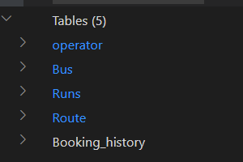

Operator Details along with sample input:

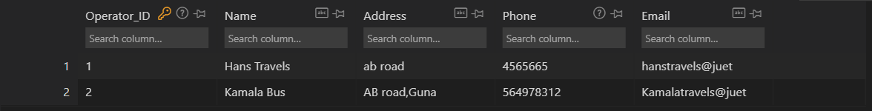

Bus details with sample inputs:

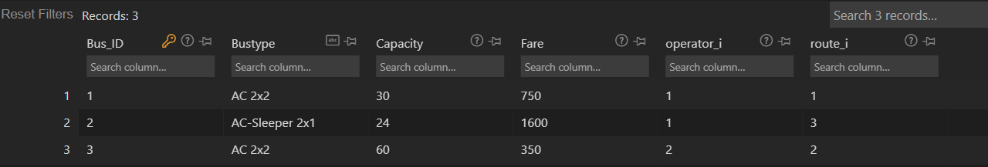

Runs details along with sample inputs:

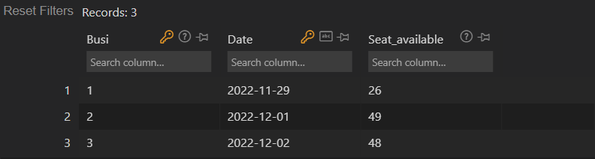

Routes detail along with sample inputs:

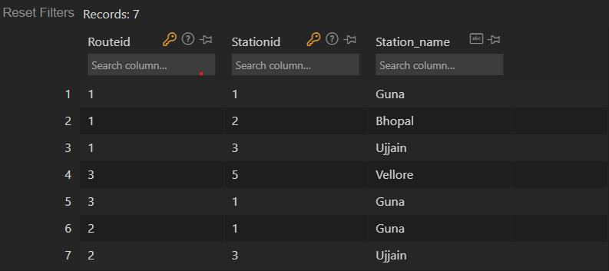

Passenger details along with some sample bookings:



Operator Table : OperatorID(Primary Key)

Bus Table : Bus ID(Primary key),Operator_i(Foreign key) references operator(OperatorID)

Runs Table : Primary Key(Busi + Date)

Route Table : Primary Key( Routeid+Stationid) ,Routeid Foreign key references Bus(Route_i)

Booking_history Table: Mobile (Primary Key)